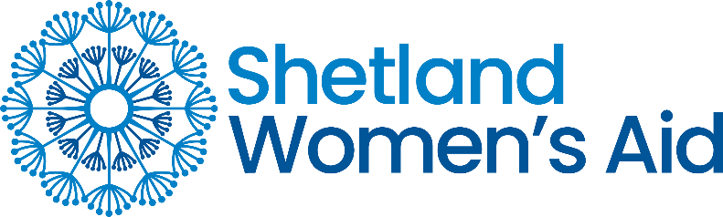

Shetland Women’s Aid – Privacy Notice
Shetland Women’s Aid (SWA) is committed to protecting your privacy. This notice explains what personal information we collect, how we use it, and your rights.
Who we are
SWA provides support to women, children, and young people experiencing domestic abuse. We act as a Data Controller, which means we decide how your personal information is used.
What information we collect
We may collect and store:
- Your contact details (name, address, phone, email).
- Information relevant to the support we provide (e.g. health, housing, family situation, safeguarding needs).
- Information about our employees, volunteers, and applicants.
- On occasion, information about perpetrators as required for safeguarding.
Why we use your information
We use your personal information to:
- Provide safe and effective services and support.
- Meet our legal and contractual obligations (e.g. safeguarding, employment law).
- Keep records and manage our organisation responsibly.
We only collect what is necessary, and we keep it secure.

Sharing your information
We may share information where there is a legal duty or to keep you or others safe (e.g. with police, social work, MARAC). We do not share your details for marketing.
How long we keep your information
We keep information only for as long as necessary, in line with legal requirements and our data retention schedule. When no longer required, it is securely destroyed.
Your rights
You have the right to:
- Be informed about how we use your data.
- Access the information we hold about you (Subject Access Request).
- Ask us to correct inaccurate data.
- Ask us to delete data we no longer need (“right to be forgotten”).
- Restrict or object to certain types of processing.
To make a request, please contact the Service Manager at office@shetlandwa.org

