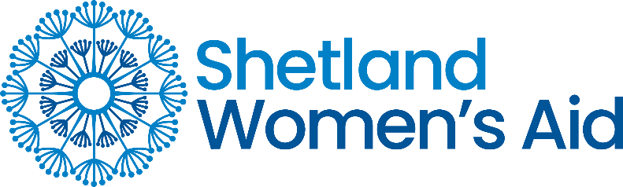

Referral Form

This form should be completed with the full agreement of the women, young person or parent of child wishing to access Shetland Women’s Aid. Forms can be returned to office@shetlandwa.org or delivered to 121a St Olaf Street, Lerwick, Shetland, ZE1 0ES

Referrer contact details:
Name:
Date:
Organisation (if applicable):
Relationship to person requiring support:
Telephone No:
Email:

Contact details for person requiring support:
Name:
Date of birth:
Home Tel. No:
Mobile No:
Email:
Is it safe to leave a voicemail?
Is it safe to text?
Is it safe to send an email?

Any other contact information? i.e., times person is unavailable

Shetland Women’s Aid provide a range of support for Women and children affected by domestic abuse. Our support services are available to anyone in Shetland and can be provided face to face, by phone, text, and email.
If you feel the person is at immediate risk of harm, please be aware we cannot respond in emergencies and 999 should be called first during any incident.
Is the abuse current?

Please provide a summary of your reasons for referring this person to SWA:

Is there any other information you feel we need to know?

What happens next? Once we receive this referral Shetland Women’s Aid will attempt to make contact within 2 weeks, (urgent safety needs will be prioritised) with the person to offer them an assessment appointment. This appointment will be an opportunity for them to find out more about the services we offer and for us to find out more about what they need.
If we cannot contact the person being referred, we will contact you (referrer) before deciding to close the file.
Useful numbers to pass to the person waiting for assessment are:
Domestic abuse 24-hour helpline: 0800 027 1234
Housing: 01595 744360
Children and families social work team: 01595 744000
Samaritans 24-hour helpline: 116 123
If you have any questions about this form or the support, we provide please contact us on 01595 692070 or email office@shetlandwa.org to discuss further.
Shetland Women’s Aid - Registered Charity No. SCO15199

